**Standing Up an Apache Web Server EC2 Instance and Sending Logs to Amazon CloudWatch**

**Hands-on Lab**

During this hands-on lab project, we are going to work on configuring an Amazon EC2 instance to push some custom log files to Amazon CloudWatch using the CloudWatch agent. Once the log files are correctly configured to be sent to Amazon CloudWatch, we will then implement a simple alerting system to catch some specific warnings and error messages using Metric Filters and Amazon SNS notifications.

**Objectives**

* Install and Configure the Amazon CloudWatch Agent
* Create a Metric Filter for 404 Status Codes
* Create SNS Topic and CloudWatch Alarm

**Architecture**

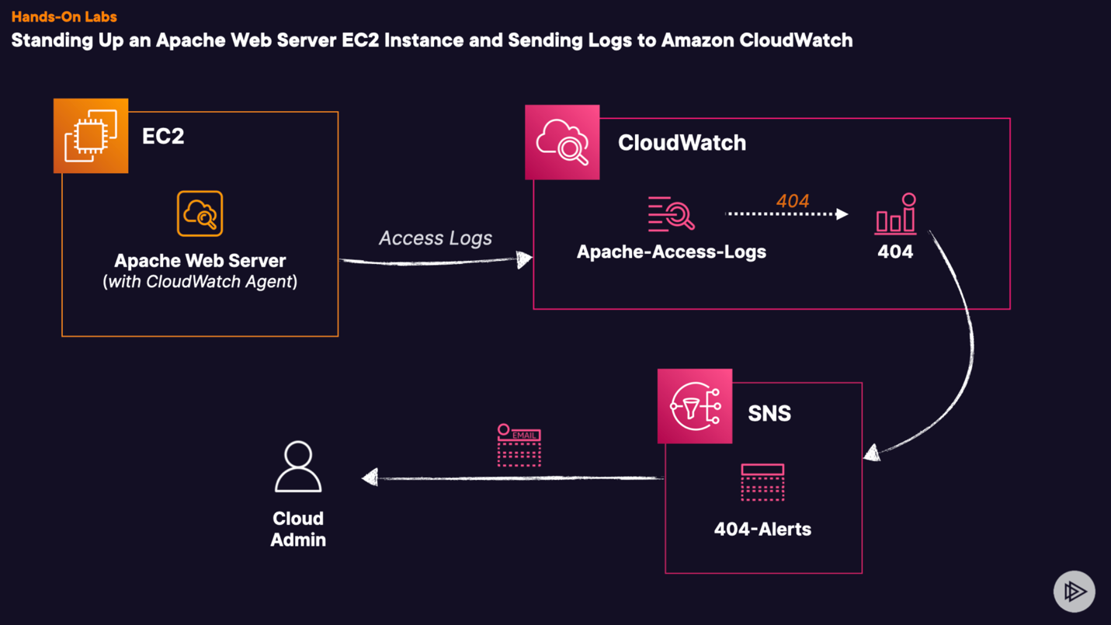

We are going to have a base structure of an Application Web Server, this architecture is going to contain an EC2 instance (Amazon Linux AMI, t3 medium), VPC, Route Table, NACL, Security Group with HTTP inbound rule (port 80)

The EC2 is going to have install httpd and index.html with the Hello Gurus page.

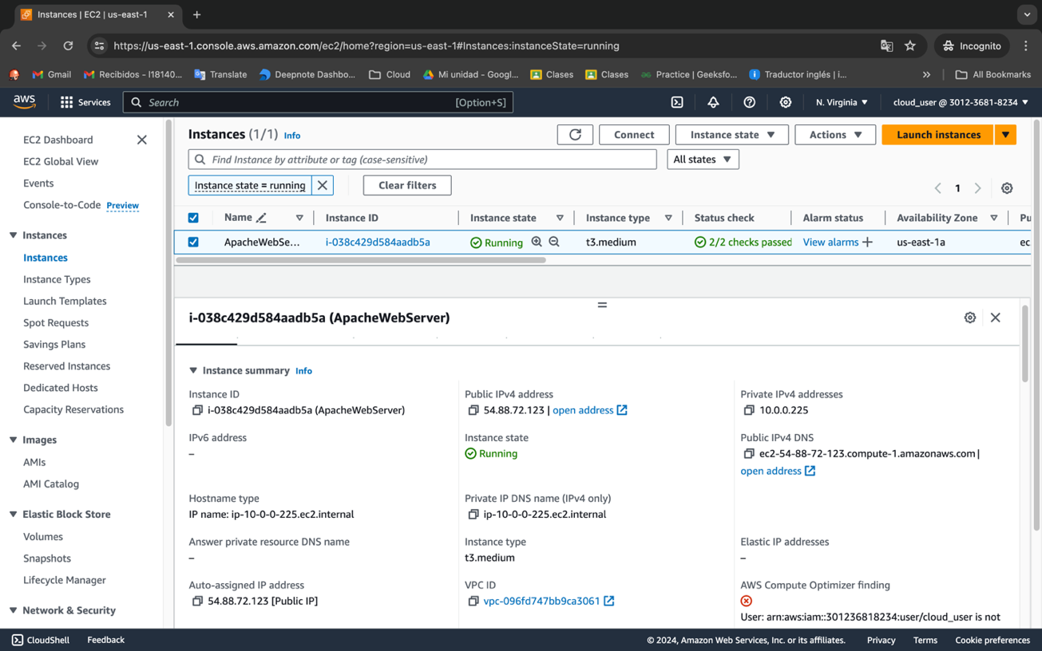

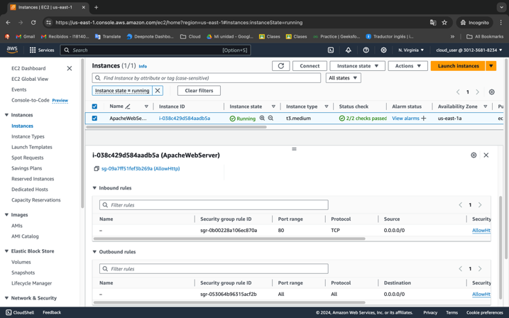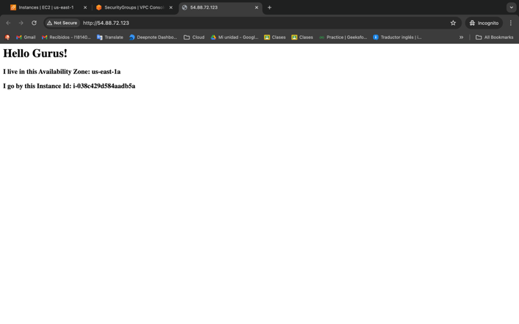

First we need to install the CloudWatch agent to monitor customs logs, so we are going to connect the instance with Session Manager

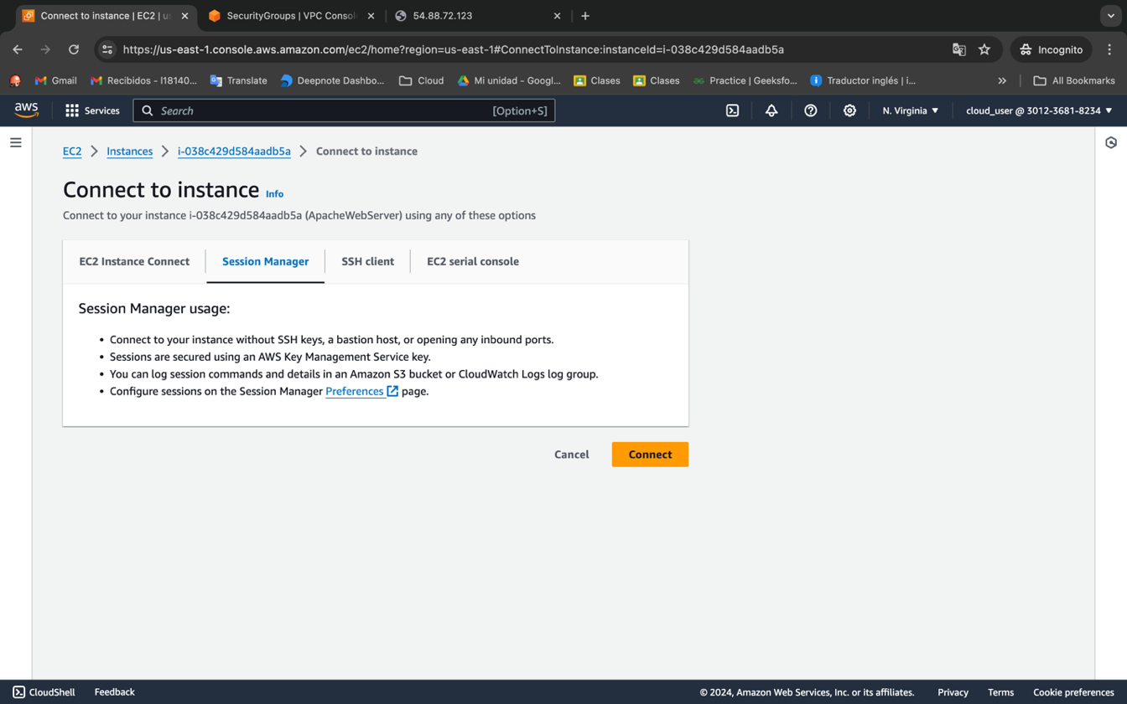

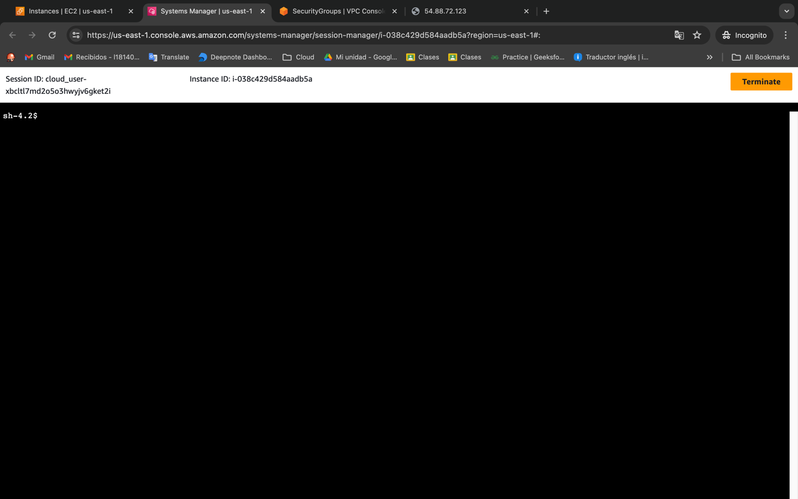

Once we are in the console we need to install the agent with the next command, optionally before this you can check updates of your system

*sudo yum install -y amazon-cloudwatch-agent*

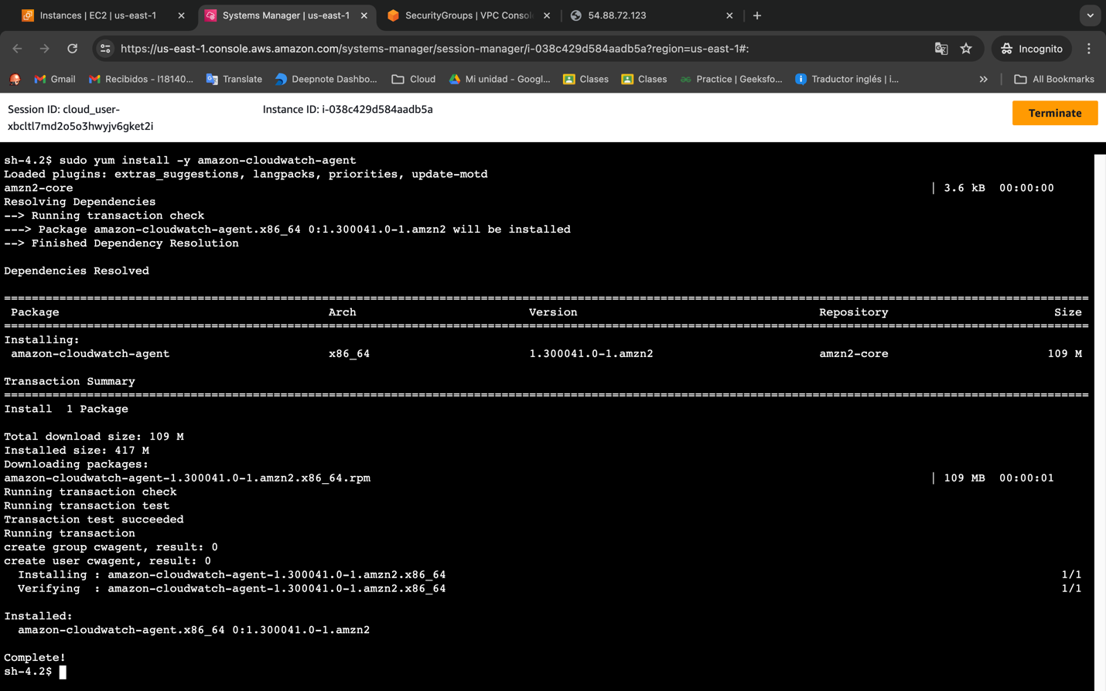

Now to configurate this agent we just installed we need to set up the configure file that is store in /tmp/cloudwatch-agent-config.json.

For this file we are going to create a log group called Apache-Access-Logs, in this group we can add all the instances that have Apache install for save the logs files, we can identified each log stream with the id of the instance

*sudo vim /tmp/cloudwatch-agent-config.json*

{

"logs": {

"logs_collected": {

"files": {

"collect_list": [

{

"file_path": "/var/log/httpd/access_log",

"log_group_name": "Apache-Access-Logs",

"log_stream_name": "{instance_id}"

}

]

}

}

}

}

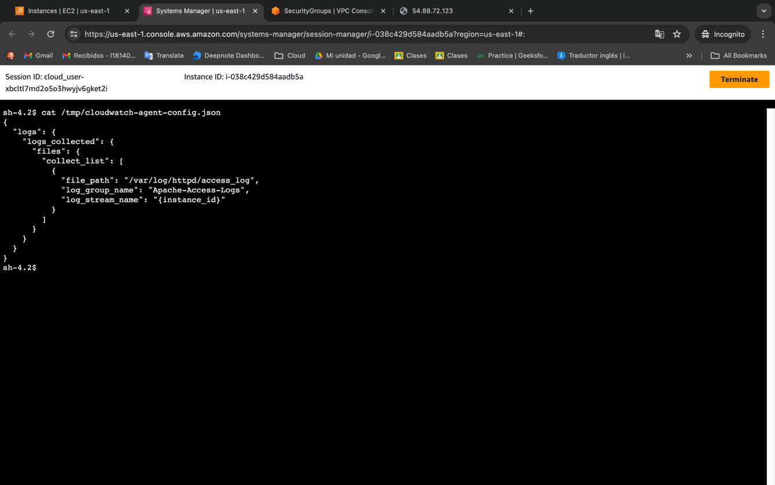

Now after install and configure the agent we need to run this agent with the next command.

*sudo /opt/aws/amazon-cloudwatch-agent/bin/amazon-cloudwatch-agent-ctl -a fetch-config -m ec2 -c file:/tmp/cloudwatch-agent-config.json -*s

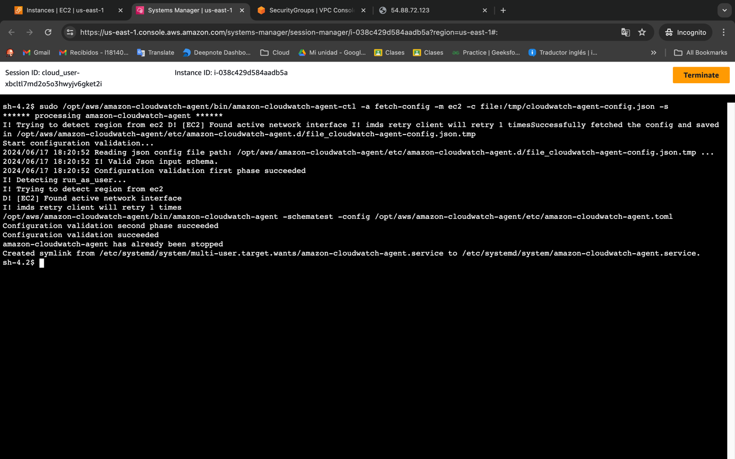

We can check our CloudWatch Log Groups dashboard and see there a new log group created an inside of this group is a log stream with the ID of our instance with all the events

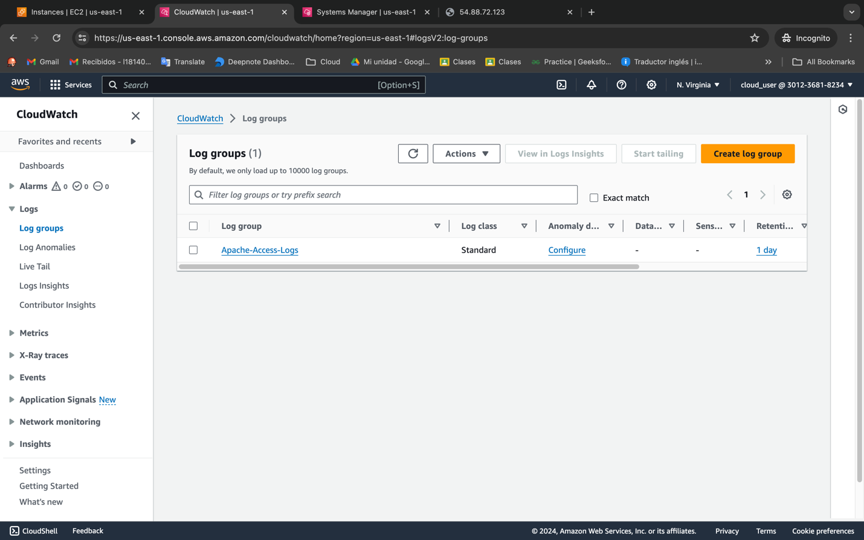

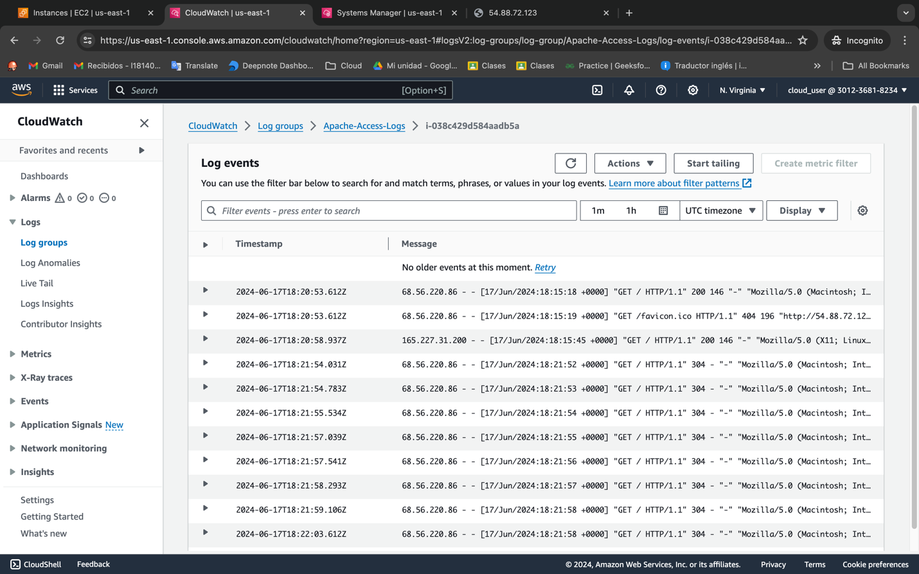

Now we can trace our events with the Live tail tool that AWS CloudWatch offers.

We are going to create new events with a fake URL. We can see the 404 error

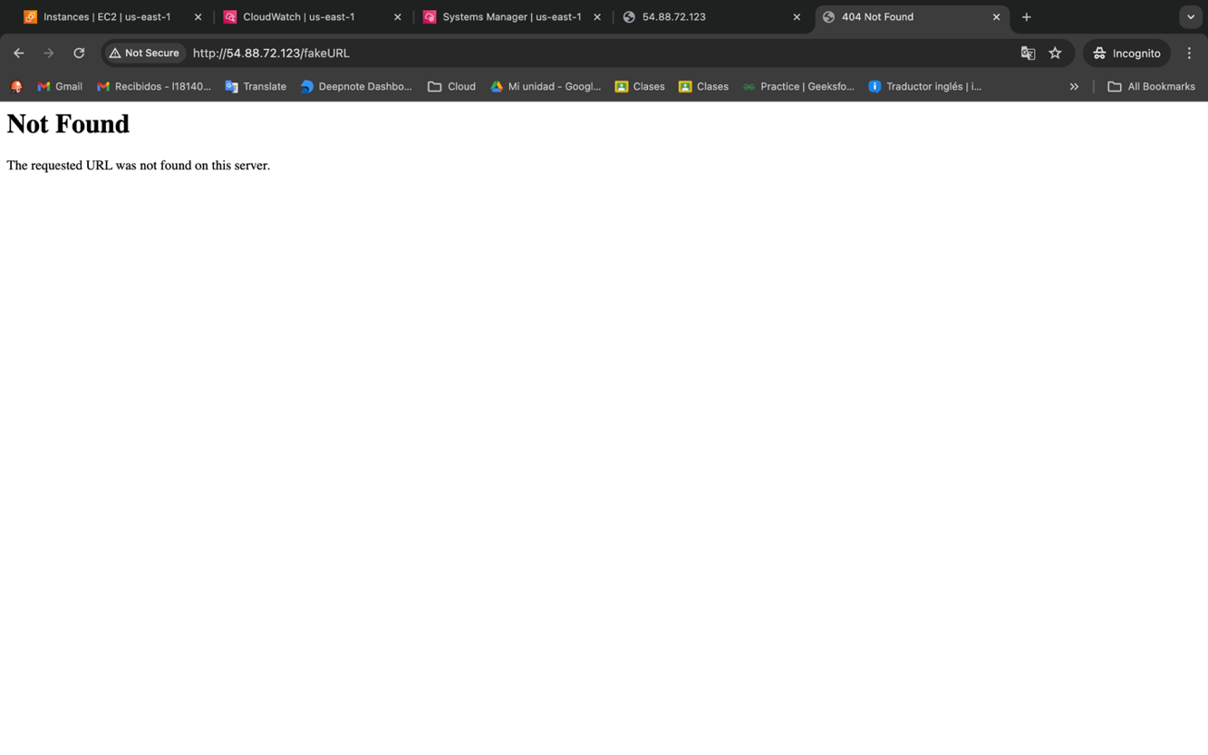

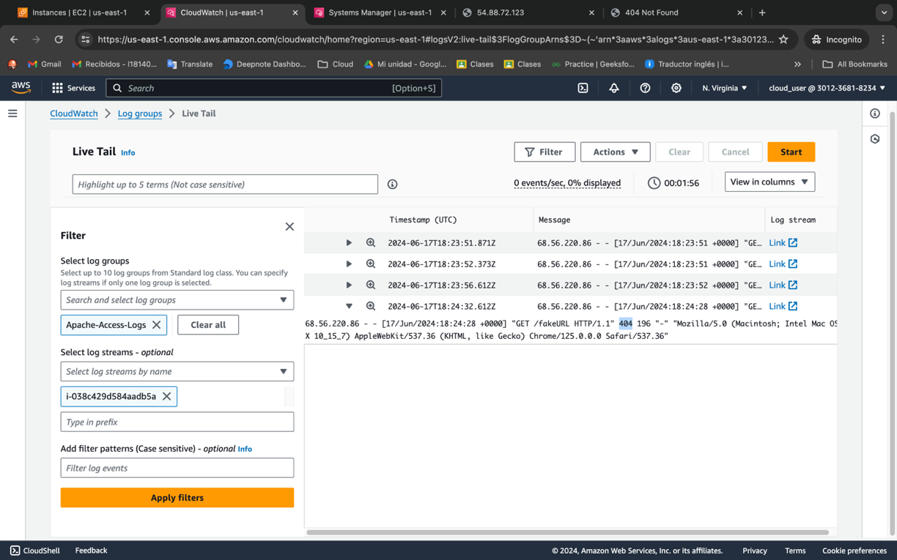

Now we need to create an Alarm that notify to the Cloud Admin each time that the web server has an error 404, so first we need to create a filter in our Apache Log group

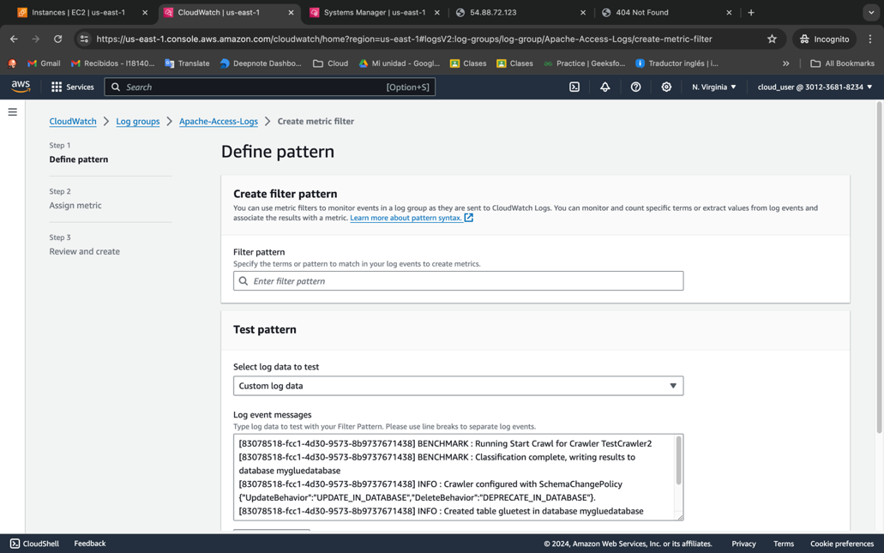

We are going to create a filter pattern with regex, that is going to search for the 404 in the log’s events. Also, we are going to test the pattern with the previous request we create with the Fake URL

*%\b404\b%*

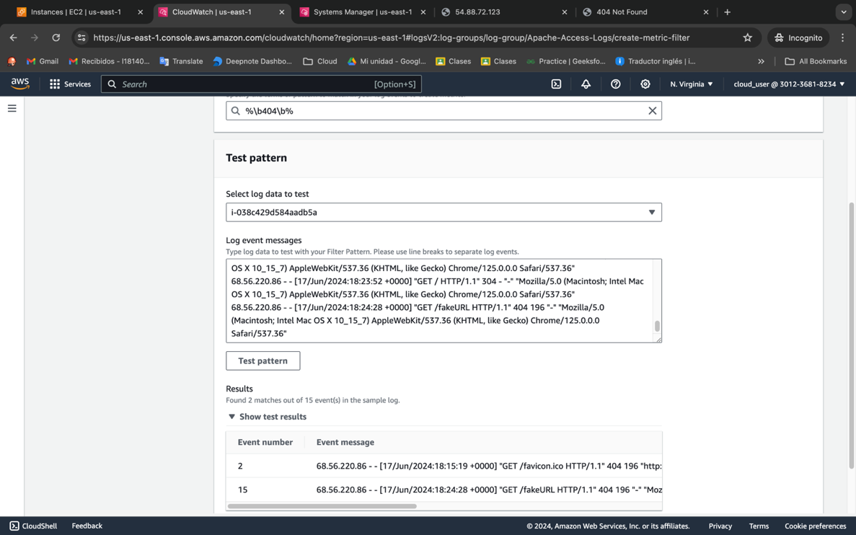

After define the filter with the pattern, we need to assign the metric details, we are going to create a new metric namespace called Apache and inside this namespace we are going to create the metric 404, the value of the metric is going to be 1 and we are going to use count unit .

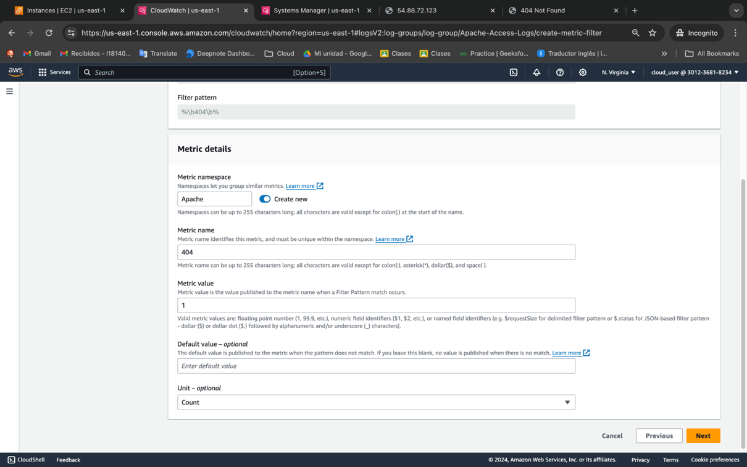

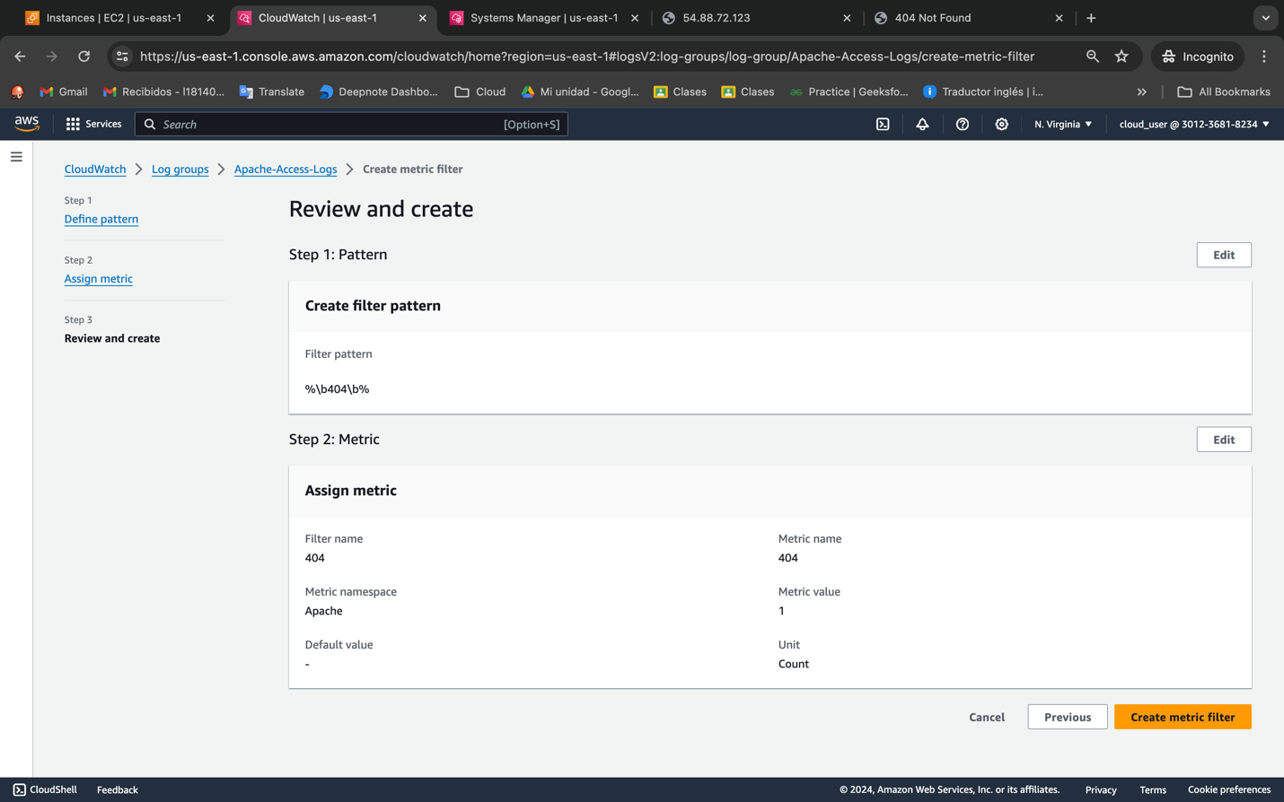

Next, we can go to our metric dashboard and if we look right away is not going to appear nothing because it takes a few minutes to receive the data.

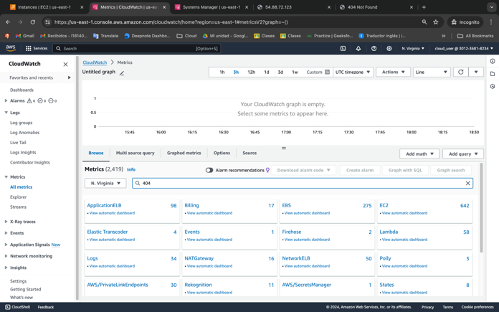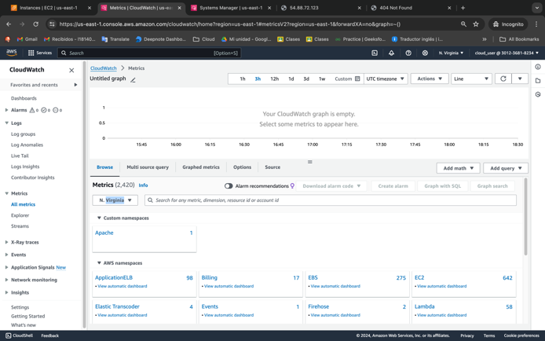

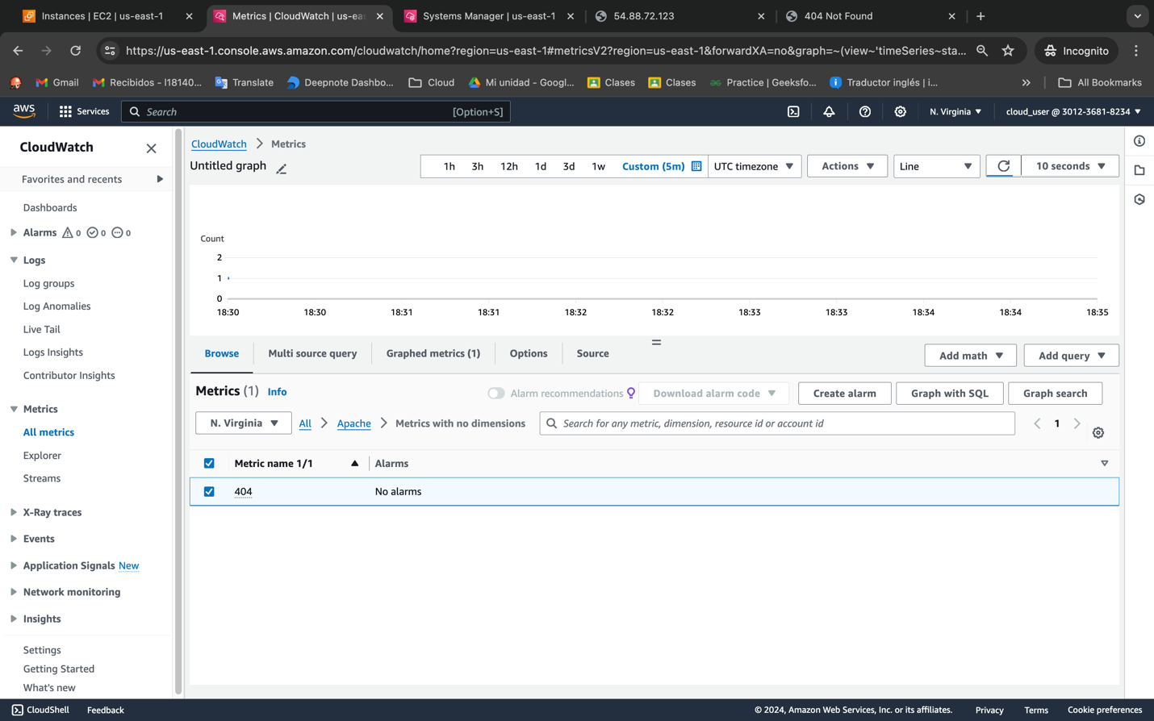

We can customize our dashboard, then after select and reload the page there is a new actions displayed on the right side, we are going to create a new alarm.

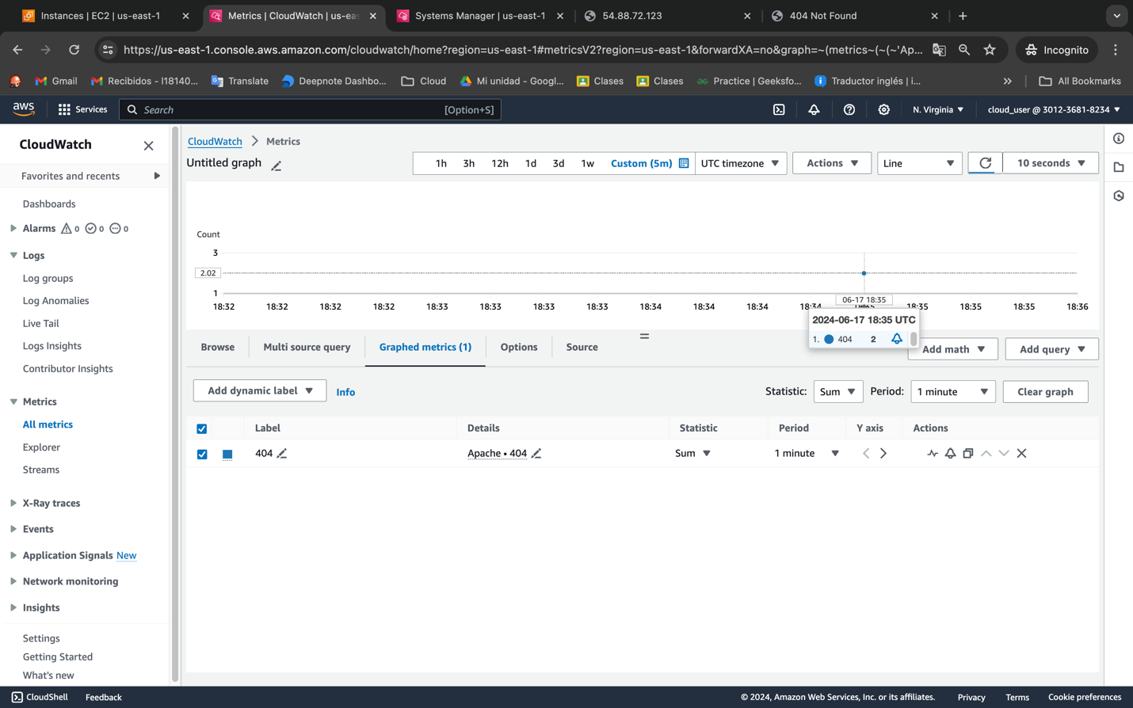

We need to create the trigger for this metric in this case we have a period of time 1 minute and Sum for statistics.

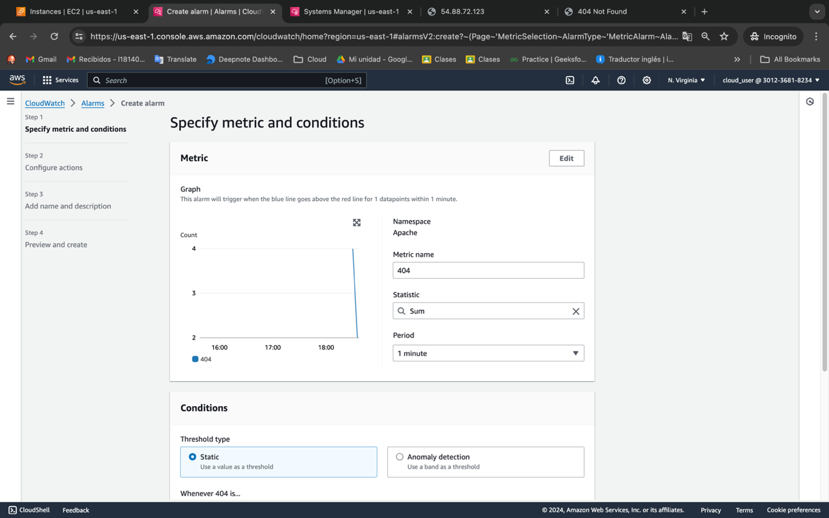

The conditions we are going to specify is every period is going to check if there is a 404 log in our filter of logs and is greater than 0

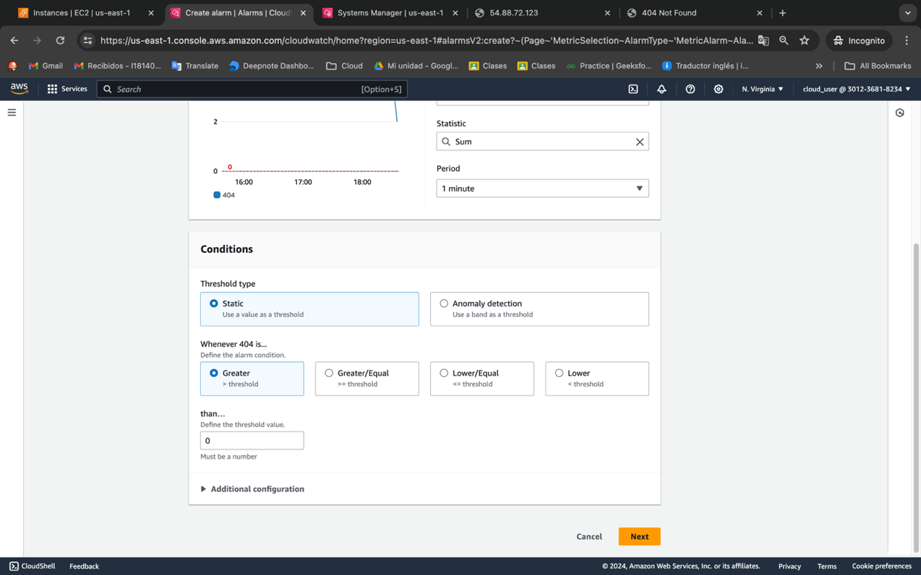

For this project I’m going to use a temporally email, to show how it works SNS and the metric with the alarm.

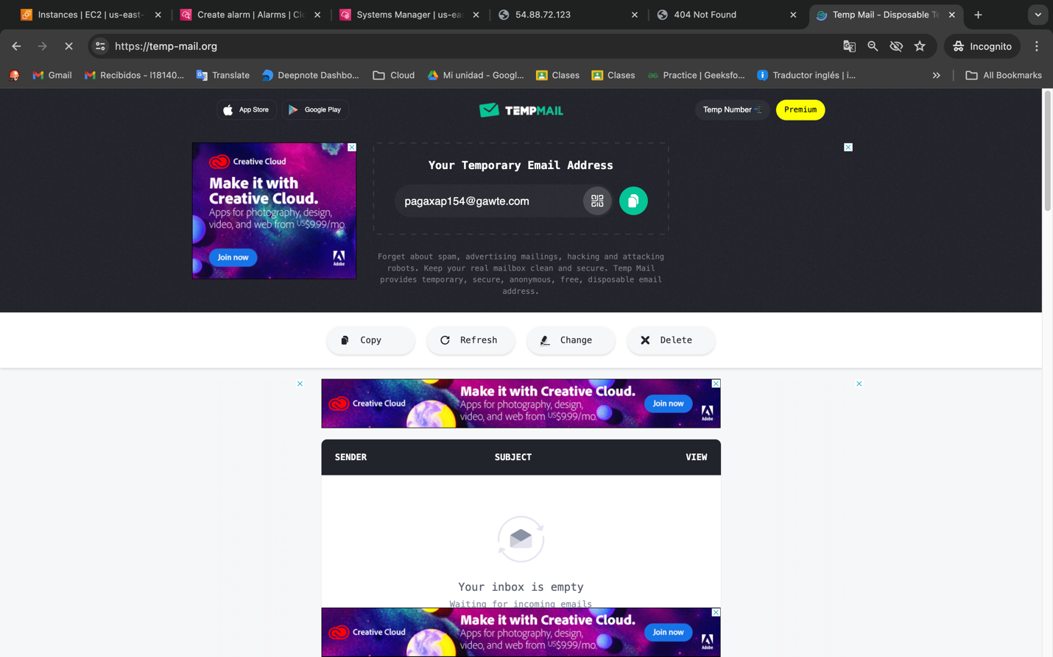

We need to configure the Alarm, we are going to create a new topic called 404-Alerts, in this SS a see the 404-Detection name and I change it later. So after that we need to add a new email in this case we add the temporally email.

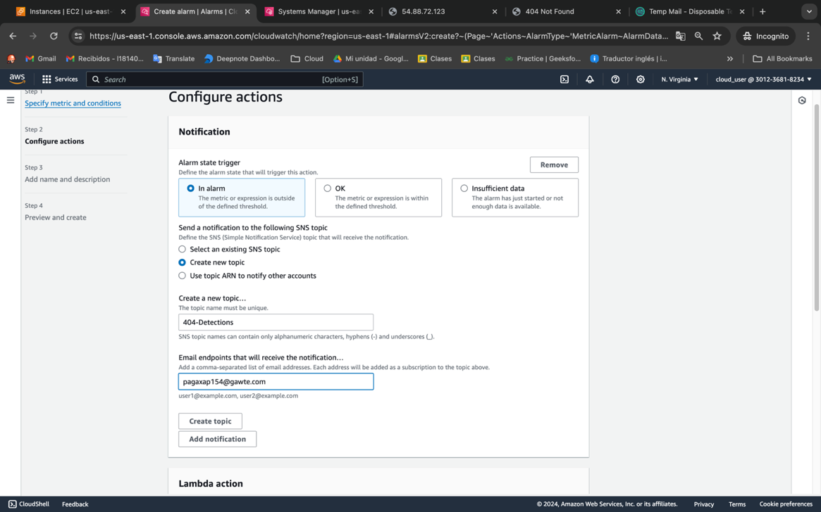

We need to confirm the subscription to the SNS topic

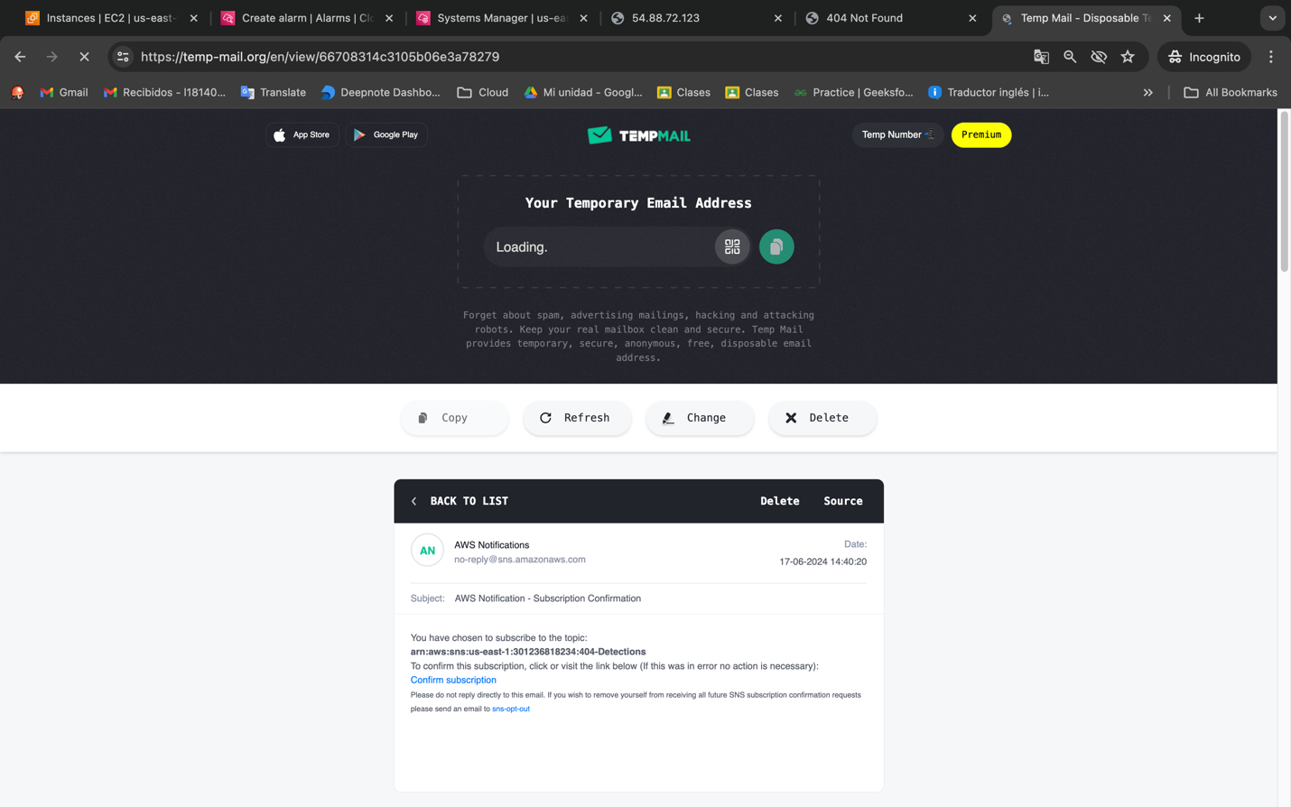

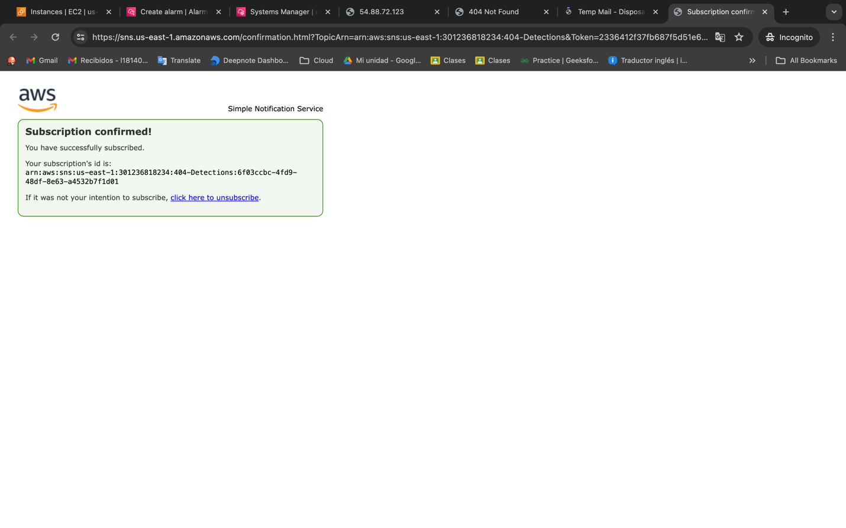

Now we have our topic called 404-Alerts with one subscription, now we only need to add a name to our alarm and check the preview.

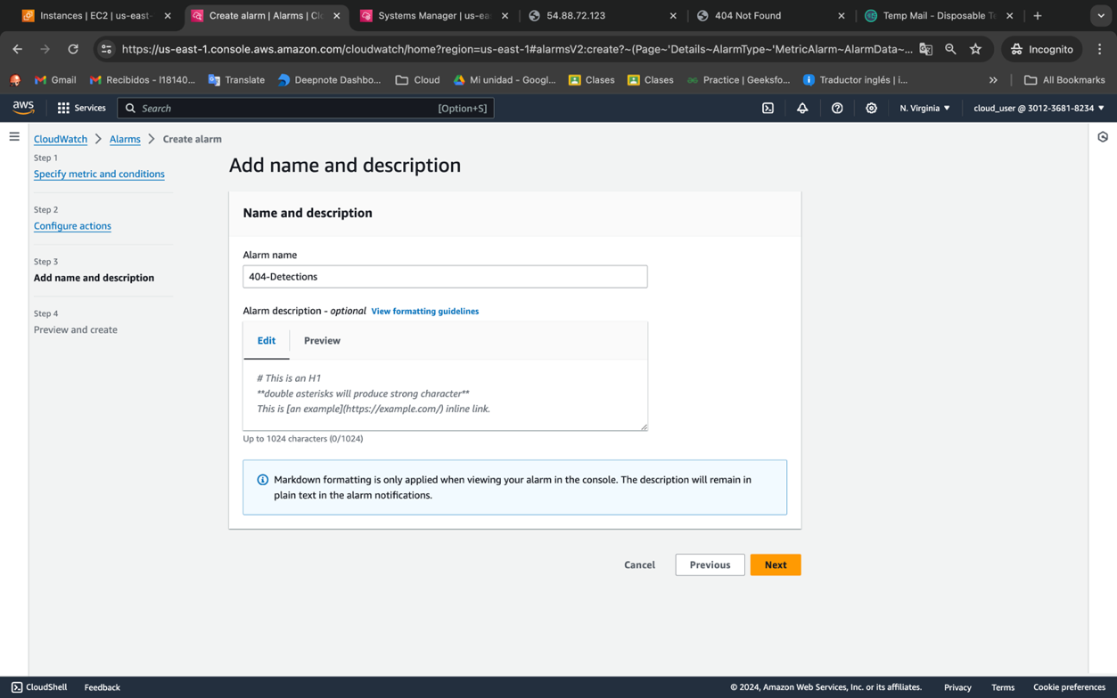

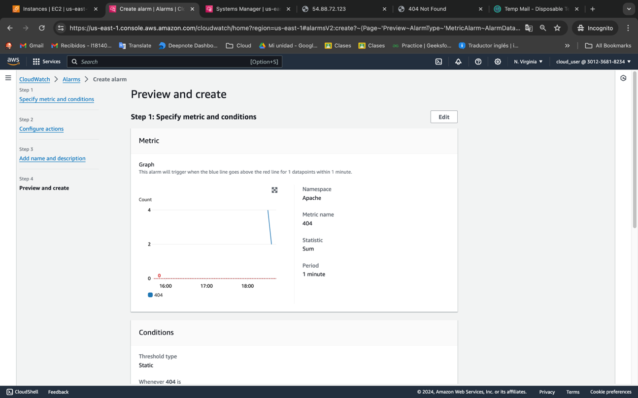

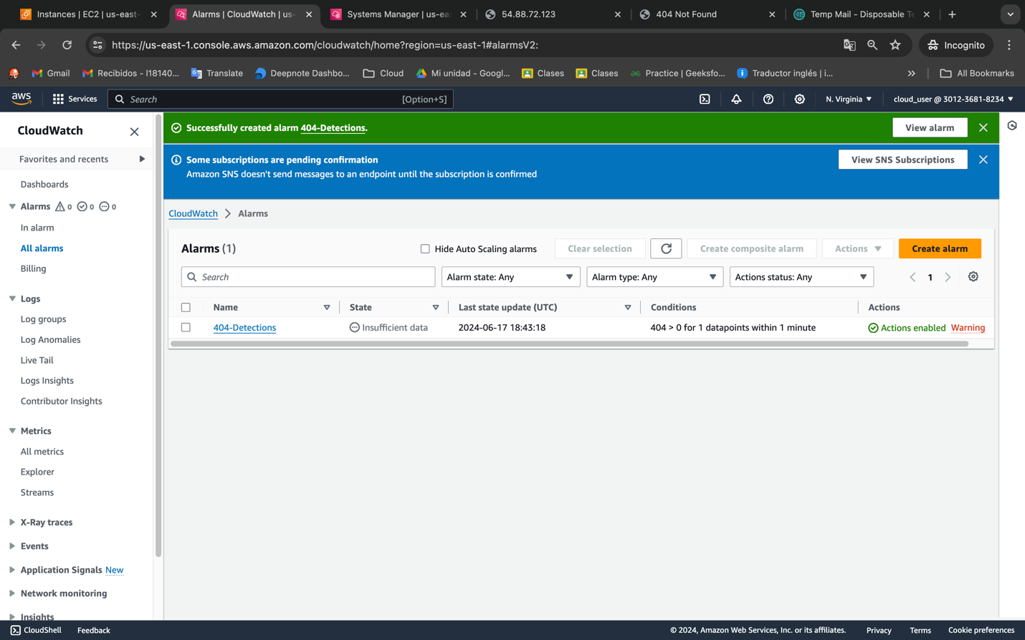

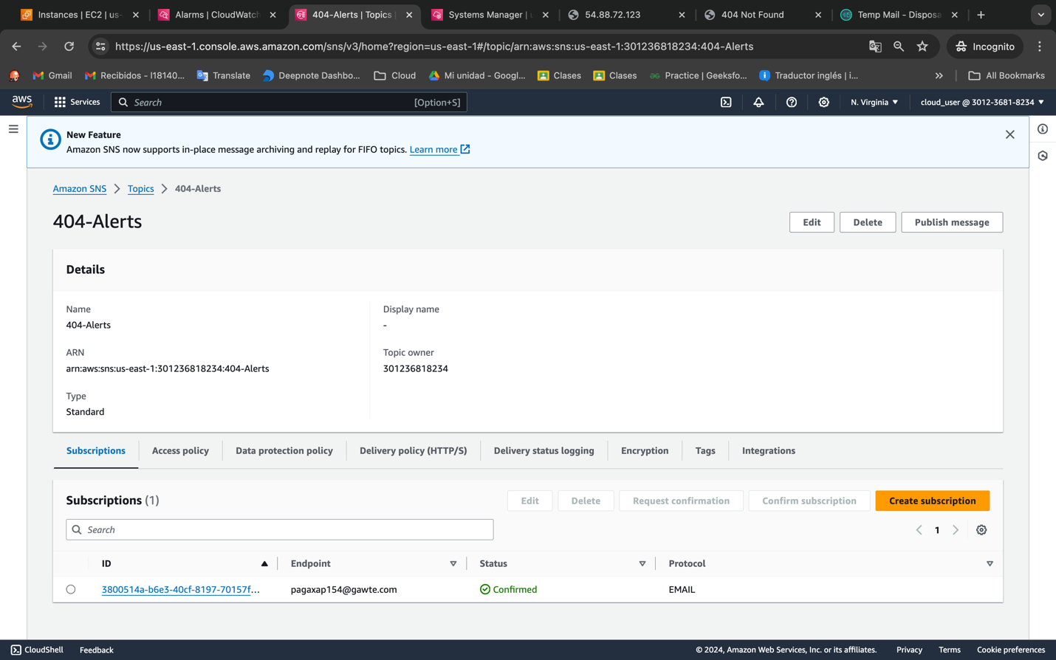

Now we create a simulation of 404 error introducing a fake URL.

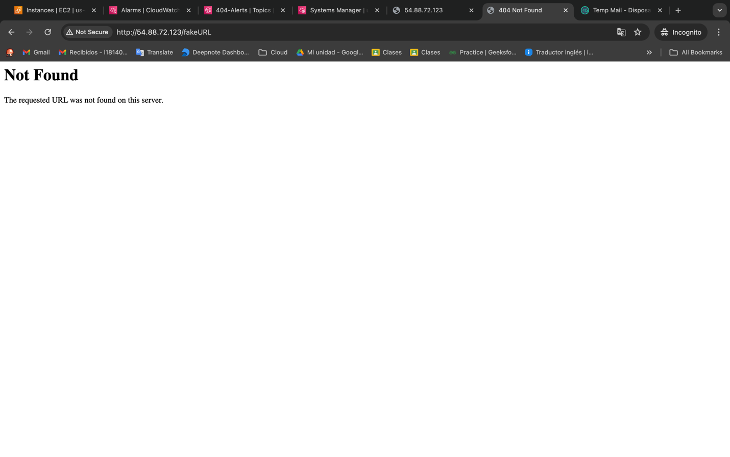

We can check the dashboard and see there is a 404 error and after catch th error we are going to receive an email.

